**Set-up Tasks Before Class**

You will need to install two pieces of software **before coming to class**. The first is R, which is the core software. The second is RStudio, which is a user-friendly wrapper around R. Both are free.

**Step 1: Install R**

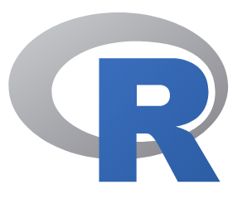

R is available for download at <https://cloud.r-project.org/>

* Select one of “Download R for (Mac) OS X” or “Download R for Windows”.
* If you use a Mac, download the most recent version of R (a .pkg file, at this time 4.2.2).
* If you use Windows, click base, and then “Download R 4.2.2 for Windows”.
* Follow the installation instructions. The default settings should be fine.
* (You probably don’t need a shortcut on your desktop; we’ll never open this one)

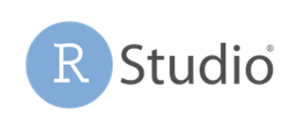**Step 2: Install RStudio**

After R has completed installing, install RStudio.

* RStudio is available for download at <http://www.rstudio.com/download>
* Download and install the free RStudio Desktop (Open Source License).

*Try it out!*

Once the above are installed, you can confirm that everything worked by opening RStudio. You should see a screen that looks like this:



Congratulations! You’re ready to do some data science.

**Step 3: Download the files from github.**

All resources for the workshop are published at <https://github.com/jtannen/r-for-datascience>

We will also work with two datasets.

* Download “Properties (CSV)” from <https://www.opendataphilly.org/dataset/opa-property-assessments>
* Download the ACS Microdate for Phila from <https://github.com/jtannen/r-for-datascience/blob/main/session-1/acs_phila_2015_5yr.csv>